**MOBILE APPLICATION DEVELOPMENT**

**(MAD)**

Name : Sourjadip Pramanik

Div: R

Roll_No : 53

ASSIGNMENT NO.3

# Assignment Name : Develop a native calculator application.

Code For Manifest File :

<?*xml version*="1.0" *encoding*="utf-8"?>

<manifest *xmlns:android*="http://schemas.android.com/apk/res/android"

*package*="com.example.calculator_1">

<application

*android:allowBackup*="true"

*android:icon*="@mipmap/ic_launcher"

*android:label*="@string/app_name"

*android:roundIcon*="@mipmap/ic_launcher_round"

*android:supportsRtl*="true"

*android:theme*="@style/Theme.Calculator_1">

<activity *android:name*=".MainActivity">

<intent-filter>

<action *android:name*="android.intent.action.MAIN" />

<category *android:name*="android.intent.category.LAUNCHER" />

</intent-filter>

</activity>

</application>

</manifest>

Code For XML File : (activity_main.xml)

<?*xml version*="1.0" *encoding*="utf-8"?>

<TableLayout *xmlns:app*="http://schemas.android.com/apk/res-auto"

*xmlns:tools*="http://schemas.android.com/tools"

*xmlns:android*="http://schemas.android.com/apk/res/android"

*android:orientation*="vertical"

*android:layout_width*="match_parent"

*android:layout_height*="match_parent"

*tools:context*=".MainActivity">

<EditText

*android:id*="@+id/edit"

*android:layout_width*="match_parent"

*android:layout_height*="wrap_content"

*android:layout_weight*="1"

*android:ems*="10"

*android:background*="@color/black"

*android:textColor*="@color/white"

*android:textSize*="34pt"

*android:gravity*="end|center"

*android:inputType*="number"

*android:text*="@string/edit_0"

*android:autofillHints*="False"

*tools:ignore*="LabelFor,UsingOnClickInXml" />

<TableLayout

*android:layout_width*="match_parent"

*android:layout_height*="wrap_content"

*android:background*="@color/black">

<TableRow

*android:layout_width*="match_parent"

*android:layout_height*="match_parent">

<Button

*android:id*="@+id/clear"

*style*="?android:attr/buttonBarButtonStyle"

*android:layout_width*="50pt"

*android:layout_height*="42pt"

*android:layout_margin*="2pt"

*android:layout_weight*="1"

*android:background*="@drawable/circle"

*android:backgroundTint*="#474242"

*android:fontFamily*="sans-serif-thin"

*android:gravity*="clip_horizontal|center|clip_vertical"

*android:onClick*="clear_content"

*android:text*="@string/clear"

*android:textColor*="#000000"

*android:textSize*="34sp"

*android:textStyle*="bold"

*app:backgroundTint*="#9C9696"

*app:iconTint*="#101010"

*tools:ignore*="UsingOnClickInXml">

</Button>

<Button

*android:id*="@+id/change_sign"

*style*="?android:attr/buttonBarButtonStyle"

*android:layout_width*="40pt"

*android:layout_height*="42pt"

*android:layout_margin*="3pt"

*android:layout_weight*="1"

*android:background*="@drawable/circle"

*android:backgroundTint*="#474242"

*android:fontFamily*="sans-serif-condensed"

*android:gravity*="clip_horizontal|center|clip_vertical"

*android:onClick*="operation"

*android:text*="@string/power"

*android:textColor*="#121111"

*android:textSize*="34sp"

*app:backgroundTint*="#9C9696"

*tools:ignore*="UsingOnClickInXml">

</Button>

<Button

*android:id*="@+id/percentage"

*style*="?android:attr/buttonBarButtonStyle"

*android:layout_width*="40pt"

*android:layout_height*="42pt"

*android:layout_margin*="2pt"

*android:layout_weight*="1"

*android:background*="@drawable/circle"

*android:backgroundTint*="#474242"

*android:fontFamily*="sans-serif-medium"

*android:gravity*="clip_horizontal|center|clip_vertical"

*android:onClick*="percentage"

*android:text*="@string/percent"

*android:textColor*="#121111"

*android:textSize*="34sp"

*app:backgroundTint*="#9C9696"

*tools:ignore*="UsingOnClickInXml">

</Button>

<Button

*android:id*="@+id/divide"

*style*="?android:attr/buttonBarButtonStyle"

*android:layout_width*="55pt"

*android:layout_height*="42pt"

*android:layout_margin*="4pt"

*android:layout_weight*="1"

*android:background*="@drawable/circle"

*android:backgroundTint*="#474242"

*android:fontFamily*="sans-serif-medium"

*android:gravity*="clip_horizontal|center|clip_vertical"

*android:onClick*="operation"

*android:text*="÷"

*android:textColor*="#FBFAFA"

*android:textSize*="48sp"

*app:backgroundTint*="#EF9208"

*tools:ignore*="UsingOnClickInXml">

</Button>

</TableRow>

<TableRow

*android:layout_width*="match_parent"

*android:layout_height*="match_parent" >

<Button

*android:id*="@+id/button_7"

*android:layout_width*="50pt"

*android:layout_height*="42pt"

*android:layout_margin*="2pt"

*android:layout_weight*="1"

*android:background*="@drawable/circle"

*android:backgroundTint*="#474242"

*android:gravity*="clip_horizontal|center|clip_vertical"

*android:onClick*="activity"

*android:paddingTop*="10dp"

*android:paddingBottom*="10dp"

*android:text*="@string/Seven"

*android:textSize*="34sp"

*app:backgroundTint*="#373333"

*tools:ignore*="UsingOnClickInXml">

</Button>

<Button

*android:id*="@+id/button_8"

*android:layout_width*="50pt"

*android:layout_height*="42pt"

*android:layout_margin*="3pt"

*android:layout_weight*="1"

*android:background*="@drawable/circle"

*android:backgroundTint*="#474242"

*android:gravity*="center"

*android:onClick*="activity"

*android:text*="@string/_8"

*android:textSize*="34sp"

*app:backgroundTint*="#373333"

*tools:ignore*="UsingOnClickInXml">

</Button>

<Button

*android:id*="@+id/button_9"

*android:layout_width*="50pt"

*android:layout_height*="42pt"

*android:layout_margin*="3pt"

*android:layout_weight*="1"

*android:background*="@drawable/circle"

*android:backgroundTint*="#474242"

*android:gravity*="center"

*android:onClick*="activity"

*android:text*="@string/_9"

*android:textSize*="34sp"

*app:backgroundTint*="#373333"

*tools:ignore*="UsingOnClickInXml">

</Button>

<Button

*android:id*="@+id/button_mul"

*android:layout_width*="55pt"

*android:layout_height*="42pt"

*android:layout_margin*="4pt"

*android:layout_weight*="1"

*android:background*="@drawable/circle"

*android:backgroundTint*="#474242"

*android:fontFamily*="sans-serif-black"

*android:gravity*="center"

*android:onClick*="operation"

*android:text*="@string/mull"

*android:textSize*="48sp"

*app:backgroundTint*="#EF9208"

*tools:ignore*="UsingOnClickInXml">

</Button>

</TableRow>

<TableRow

*android:layout_width*="match_parent"

*android:layout_height*="match_parent" >

<Button

*android:id*="@+id/button_4"

*android:layout_width*="50pt"

*android:layout_height*="42pt"

*android:layout_margin*="2pt"

*android:layout_weight*="1"

*android:background*="@drawable/circle"

*android:backgroundTint*="#474242"

*android:gravity*="center"

*android:onClick*="activity"

*android:text*="@string/_4"

*android:textSize*="34sp"

*app:backgroundTint*="#373333"

*tools:ignore*="UsingOnClickInXml">

</Button>

<Button

*android:id*="@+id/button_5"

*android:layout_width*="50pt"

*android:layout_height*="42pt"

*android:layout_margin*="3pt"

*android:layout_weight*="1"

*android:background*="@drawable/circle"

*android:backgroundTint*="#474242"

*android:gravity*="center"

*android:onClick*="activity"

*android:text*="@string/_5"

*android:textSize*="34sp"

*app:backgroundTint*="#373333"

*tools:ignore*="UsingOnClickInXml">

</Button>

<Button

*android:id*="@+id/button_6"

*android:layout_width*="50pt"

*android:layout_height*="42pt"

*android:layout_margin*="3pt"

*android:layout_weight*="1"

*android:background*="@drawable/circle"

*android:backgroundTint*="#474242"

*android:gravity*="center"

*android:onClick*="activity"

*android:text*="6"

*android:textSize*="34sp"

*app:backgroundTint*="#373333"

*tools:ignore*="UsingOnClickInXml">

</Button>

<Button

*android:id*="@+id/button_sub"

*android:layout_width*="55pt"

*android:layout_height*="42pt"

*android:layout_margin*="4pt"

*android:layout_weight*="1"

*android:background*="@drawable/circle"

*android:backgroundTint*="#474242"

*android:fontFamily*="sans-serif-black"

*android:gravity*="center"

*android:onClick*="operation"

*android:text*="-"

*android:textSize*="48sp"

*app:backgroundTint*="#EF9208"

*tools:ignore*="UsingOnClickInXml">

</Button>

</TableRow>

<TableRow

*android:layout_width*="match_parent"

*android:layout_height*="match_parent" >

<Button

*android:id*="@+id/button_1"

*android:layout_width*="50pt"

*android:layout_height*="42pt"

*android:layout_margin*="2pt"

*android:layout_marginBottom*="0pt"

*android:layout_weight*="1"

*android:background*="@drawable/circle"

*android:backgroundTint*="#474242"

*android:gravity*="center"

*android:onClick*="activity"

*android:text*="1"

*android:textSize*="34sp"

*app:backgroundTint*="#373333"

*tools:ignore*="UsingOnClickInXml">

</Button>

<Button

*android:id*="@+id/button_2"

*android:layout_width*="50pt"

*android:layout_height*="42pt"

*android:layout_margin*="3pt"

*android:layout_weight*="1"

*android:background*="@drawable/circle"

*android:backgroundTint*="#474242"

*android:gravity*="center"

*android:onClick*="activity"

*android:text*="2"

*android:textSize*="34sp"

*app:backgroundTint*="#373333"

*tools:ignore*="UsingOnClickInXml">

</Button>

<Button

*android:id*="@+id/button_3"

*android:layout_width*="50pt"

*android:layout_height*="42pt"

*android:layout_margin*="3pt"

*android:layout_weight*="1"

*android:background*="@drawable/circle"

*android:backgroundTint*="#474242"

*android:gravity*="center"

*android:onClick*="activity"

*android:text*="3"

*android:textSize*="34sp"

*app:backgroundTint*="#373333"

*tools:ignore*="UsingOnClickInXml">

</Button>

<Button

*android:id*="@+id/button_add"

*android:layout_width*="55pt"

*android:layout_height*="42pt"

*android:layout_margin*="4pt"

*android:layout_weight*="1"

*android:background*="@drawable/circle"

*android:backgroundTint*="#474242"

*android:fontFamily*="sans-serif-medium"

*android:gravity*="center"

*android:onClick*="operation"

*android:text*="+"

*android:textSize*="48sp"

*app:backgroundTint*="#EF9208"

*tools:ignore*="UsingOnClickInXml">

</Button>

</TableRow>

</TableLayout>

<LinearLayout

*android:layout_width*="match_parent"

*android:layout_height*="wrap_content"

*android:orientation*="horizontal"

*android:background*="@color/black">

<TableRow

*android:layout_marginBottom*="8pt"

*android:layout_width*="match_parent"

*android:layout_height*="match_parent" >

<Button

*android:id*="@+id/button_0"

*android:layout_width*="200pt"

*android:layout_height*="42pt"

*android:layout_margin*="3pt"

*android:layout_weight*="10"

*android:background*="@drawable/rectangle"

*android:backgroundTint*="#474242"

*android:gravity*="center"

*android:onClick*="activity"

*android:text*="0"

*android:textSize*="34sp"

*app:backgroundTint*="#373333"

*tools:ignore*="UsingOnClickInXml">

</Button>

<Button

*android:id*="@+id/button_decimal"

*android:layout_width*="50pt"

*android:layout_height*="42pt"

*android:layout_margin*="3pt"

*android:layout_weight*="1"

*android:background*="@drawable/circle"

*android:backgroundTint*="#474242"

*android:gravity*="center"

*android:onClick*="activity"

*android:text*="."

*android:textSize*="48sp"

*app:backgroundTint*="#373333"

*tools:ignore*="UsingOnClickInXml">

</Button>

<Button

*android:id*="@+id/button_equal"

*android:layout_width*="55pt"

*android:layout_height*="42pt"

*android:layout_margin*="4pt"

*android:layout_weight*="1"

*android:background*="@drawable/circle"

*android:backgroundTint*="#474242"

*android:fontFamily*="sans-serif-black"

*android:gravity*="center"

*android:onClick*="click_equal"

*android:text*="="

*android:textSize*="48sp"

*app:backgroundTint*="#EF9208"

*tools:ignore*="UsingOnClickInXml">

</Button>

</TableRow>

</LinearLayout>

</TableLayout>

Code For **Drawable** (XML File) : (rectangle.xml)

<?*xml version*="1.0" *encoding*="utf-8"?>

<selector *xmlns:android*="http://schemas.android.com/apk/res/android">

<item>

<shape *android:shape*="rectangle">

<solid *android:color*="#222020"/>

<corners *android:radius*="1000dp"/>

</shape>

</item>

</selector>

Code For **Drawable** (XML File) : (circle.xml)

<?*xml version*="1.0" *encoding*="utf-8"?>

<selector *xmlns:android*="http://schemas.android.com/apk/res/android">

<item>

<shape *android:shape*="oval">

<solid *android:color*="#222020"/>

<size *android:width*="15dp" *android:height*="15dp"/>

</shape>

</item>

</selector>

Code For JAVA File : (MainActivity.java)

*package* com.example.calculator_1;

*import* android.annotation.SuppressLint;

*import* android.os.Bundle;

*import* android.view.View;

*import* android.widget.EditText;

*import* androidx.appcompat.app.AppCompatActivity;

*public class* MainActivity *extends* AppCompatActivity {

EditText ed;

*boolean* input = *true*;

String op = "+";

String p_num="";

@Override

*protected void* onCreate(Bundle savedInstanceState) {

*super*.onCreate(savedInstanceState);

setContentView(R.layout.*activity_main*);

ed = findViewById(R.id.*edit*);

}

@SuppressLint("NonConstantResourceId")

*public void* activity(View view){

*if*(input)

ed.setText(" ");

input = *false*;

String number = ed.getText().toString();

*switch* (view.getId()){

*case* R.id.*button_0*:

number += "0";

*break*;

*case* R.id.*button_1*:

number += "1";

*break*;

*case* R.id.*button_2*:

number += "2";

*break*;

*case* R.id.*button_3*:

number += "3";

*break*;

*case* R.id.*button_4*:

number += "4";

*break*;

*case* R.id.*button_5*:

number += "5";

*break*;

*case* R.id.*button_6*:

number += "6";

*break*;

*case* R.id.*button_7*:

number += "7";

*break*;

*case* R.id.*button_8*:

number += "8";

*break*;

*case* R.id.*button_9*:

number += "9";

*break*;

*case* R.id.*button_decimal*:

number += ".";

*break*;

}

ed.setText(number);

}

@SuppressLint("NonConstantResourceId")

*public void* operation(View view){

input=*true*;

p_num=ed.getText().toString();

*switch*(view.getId()){

*case* R.id.*divide*: op = "÷";*break*;

*case* R.id.*button_mul*: op = "×";*break*;

*case* R.id.*button_add*: op = "+";*break*;

*case* R.id.*button_sub*: op = "-";*break*;

*case* R.id.*change_sign*: op = " ^ ";*break*;

}

}

@SuppressLint("SetTextI18n")

*public void* click_equal(View view){

String n_Num = ed.getText().toString();

*double* result = 0.0;

*switch* (op){

*case* "+":

result=Double.*parseDouble*(p_num)+Double.*parseDouble*(n_Num);

*break*;

*case* "-":

result=Double.*parseDouble*(p_num) - Double.*parseDouble*(n_Num);

*break*;

*case* "×":

result=Double.*parseDouble*(p_num) * Double.*parseDouble*(n_Num);

*break*;

*case* "÷":

result=Double.*parseDouble*(p_num) / Double.*parseDouble*(n_Num);

*break*;

*case* " ^ ":

result=Math.*pow*(Double.*parseDouble*(p_num),Double.*parseDouble*(n_Num));

*break*;

}

ed.setText(result+"");

}

*public void* clear_content(View view){

ed.setText("0");

input=*true*;

}

@SuppressLint("SetTextI18n")

*public void* percentage(View view){

*double* no = Double.*parseDouble*(ed.getText().toString())/100;

ed.setText(no+"");

input=*true*;

}

}

SCREENSHOTS :

Opening the application :

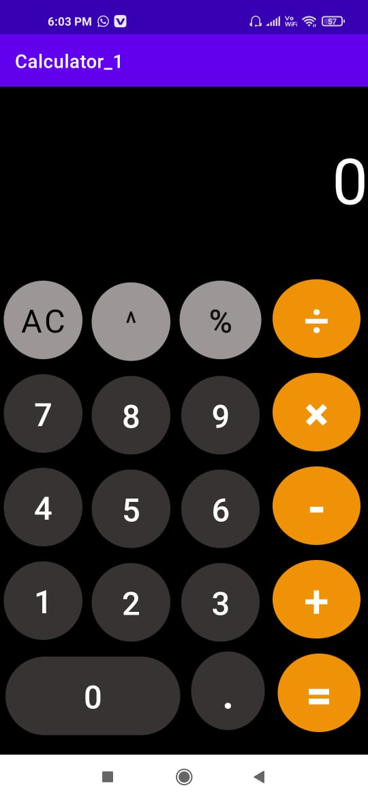

Typing with help of Buttons :

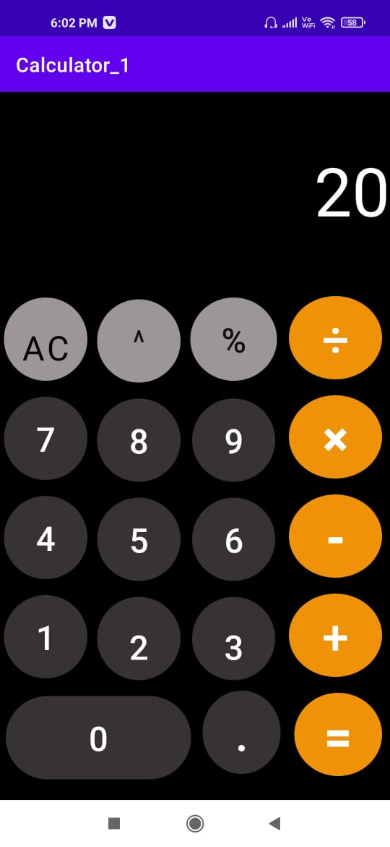

Pressing “+” button :



Typing with help of Buttons for the next number:

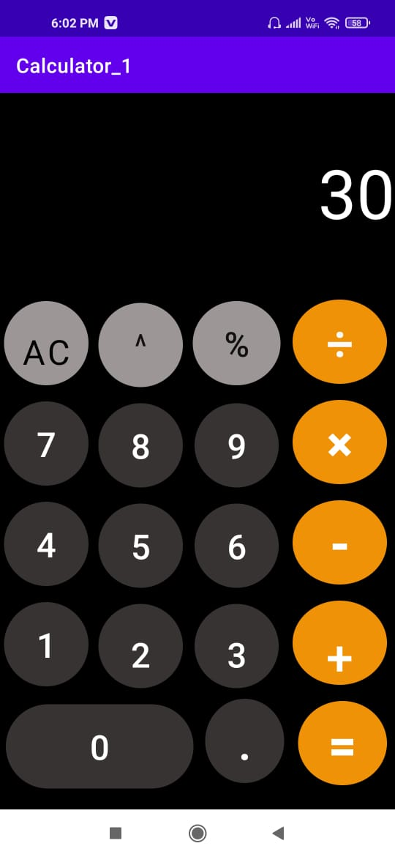

Pressing “ = ” Button

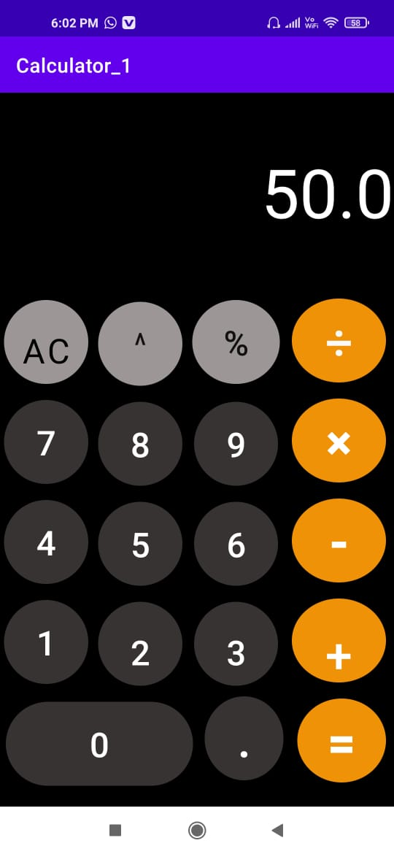

Rest All the Operators work in the similar way.